**Agency SPOC, Please fill out a separate form for each user account.** All information below should pertain to the new user unless specifically stated otherwise. Instructions are on Page 2.

|  |  |  |  |  |  |  |  |
| --- | --- | --- | --- | --- | --- | --- | --- |
| **User Account Action\***  **Check only one** | * Add user * Change user perms. * Remove user | | **Date to Apply Change** | | |  | |
| **Environment** | **Production**  **Test or UAT** | | | | | | |
| **Agency / Division\*** |  | | | | | | |
| **TPE store name or Merchant/Service** |  | | | | | | |
| **Full Name of user** |  | | | | | | |
| **Email address of user** |  | | | | | | |
| **Phone number of user** |  | | | | | | |
| **Agency Security Officer See link to list below** |  | | | Print name | | |
| **Agency Security Officer wet Signature\*** |  | | | **Print** the form, **sign here by hand, and scan** or take a picture and submit. | | |
| **Date\*** |  | | | Date of ASO Approval | | |
|  | | | | | | |
| **Standard user information and permissions** | | **SOS Custom TPE Information** | | | | |
| **Permission Level**   * Managers (search and run reports) * Managers-Refunds (Above plus add perform refunds) * Company Staff (Above plus add Cancellations) | | **Username** | | |  | | |
| **OR Number** | | |  | | |
| **Permission Level**   * All Functions * Cancel Orders * Print Transactions * View Payment History | | | | | |
|

# Instructions

Questions?

[egovhelp@oregon.gov](mailto:egovhelp@oregon.gov)  
<http://egovservicedesk.zendesk.com>  
**503-378-2126**

T**his form will not be processed without the hand written signature of the Agency Security Officer (ASO) appropriate to the requesting agency**.

The current list of Agency Security Officers is available on Oregon.gov at this URL:  
<http://www.oregon.gov/das/Financial/Acctng/Documents/Agency_Security_Officer_Contact_List.pdf>

Use the link above or type the URL above in to your web browser to find the security officer(s) associated with your agency. The officer indicated for the **R*STARS** program is the one to use for this form. The list above will be the authentication tool used for this request. Any variation from that requires separate approval from the Oregon State Treasury.

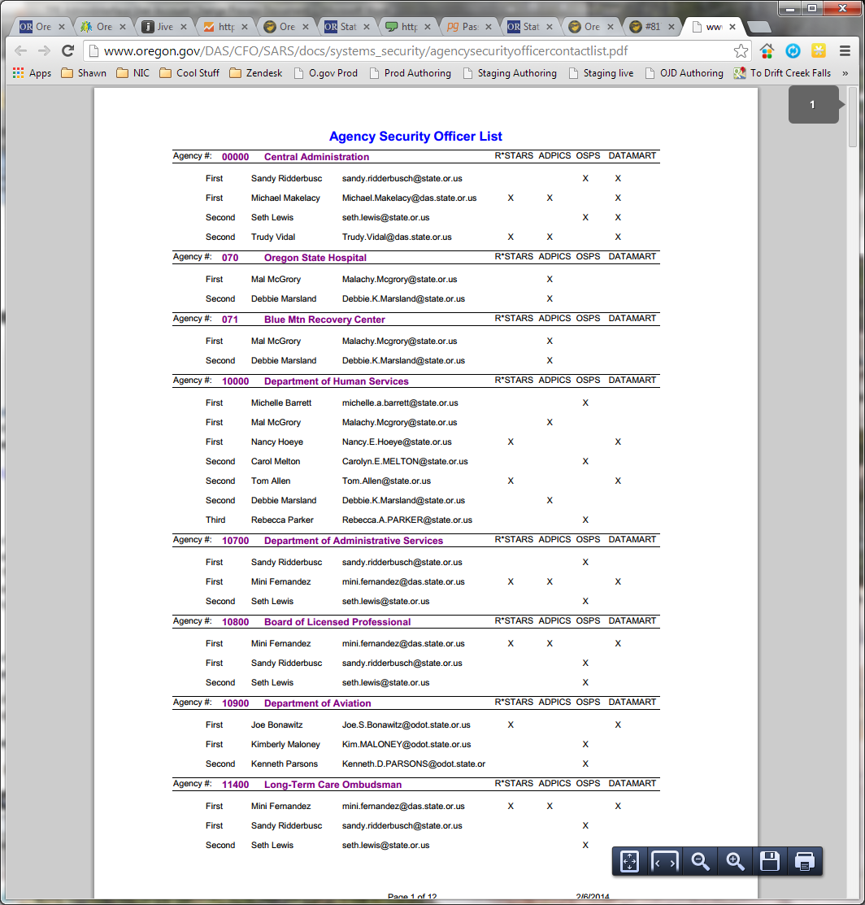

**Example:** For a request from the Department of Human Services, signatures from one of the two ASOs indicated above by yellow highlighted boxes would be required.

**It is the requester’s responsibility to acquire Security Officer and/or Oregon State Treasury approval as required.**

Each form entry noted with an asterisk is required. Please provide the information in those fields so that your request can be processed.

# Standard TPE Permissions Levels

**Company Managers** – Read Only - users can perform query/search for transactions and generate reports in TPE Admin Interface.

**Company Managers Refunds** – Above plus perform refunds against successfully processed transactions.

**Company Staff -** Above plus void/cancel transactions before the end of day settlement process.

# SOS Custom TPE Permission Levels

Used exclusively by the Secretary of State’s Office for their custom TPE interface.

# To submit the request

Submit the filled in form to the E-Government Service Desk via [egovhelp@oregon.gov](mailto:egovhelp@oregon.gov) or directly via <http://egovservicedesk.zendesk.com>. This will create the service ticket.

The Service Desk will review the request and respond with any questions that are appropriate. Once all information and approvals have been gained, the E-Gov Service Desk will:

* complete the request
* make the account holder aware of the changes that have taken place
* notify the requester that the changes have taken place (no passwords will be shared)
* close the service ticket

At this point, new users will have access to the TPE admin system. They will be required to change the provided password immediately upon their initial log in. Changes to existing users accounts should show up in the system immediately once the change is made.